SYTR GOVT DEGREE COLLEGE

MADAKASIRA

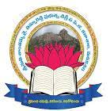

DEPARTMENT OF ENGLISH

ACADEMIC YEAR – 2021-22

CONDUCTING REMEDIAL CLASSES FOR 2 YEAR B.A & B. Sc STUDENTS

CONDUCTING CLASSES ON FUNCTIONAL ENGLISH

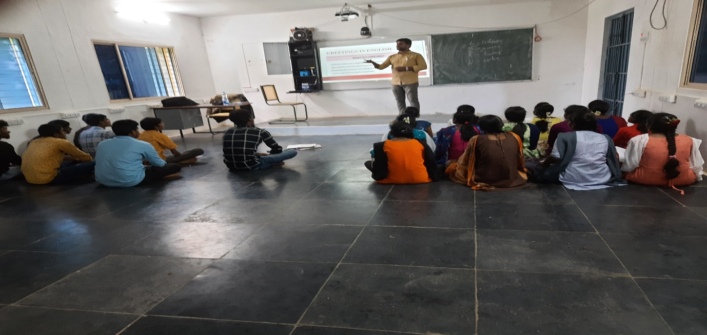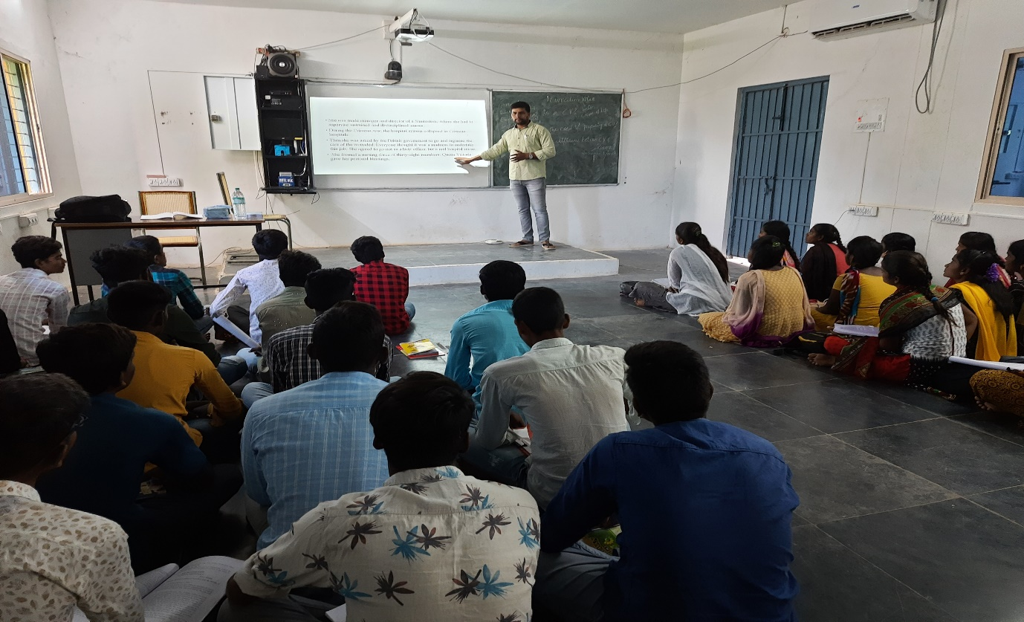
Engaging remedial classes for II B.A Students

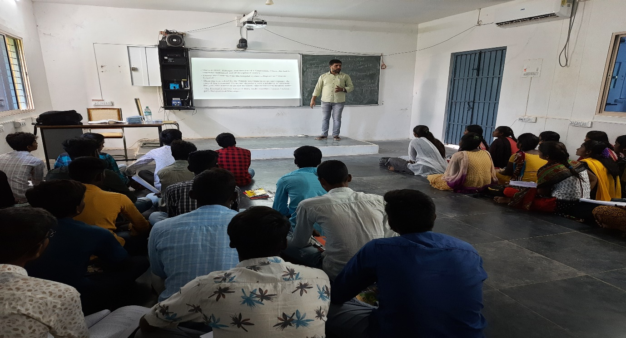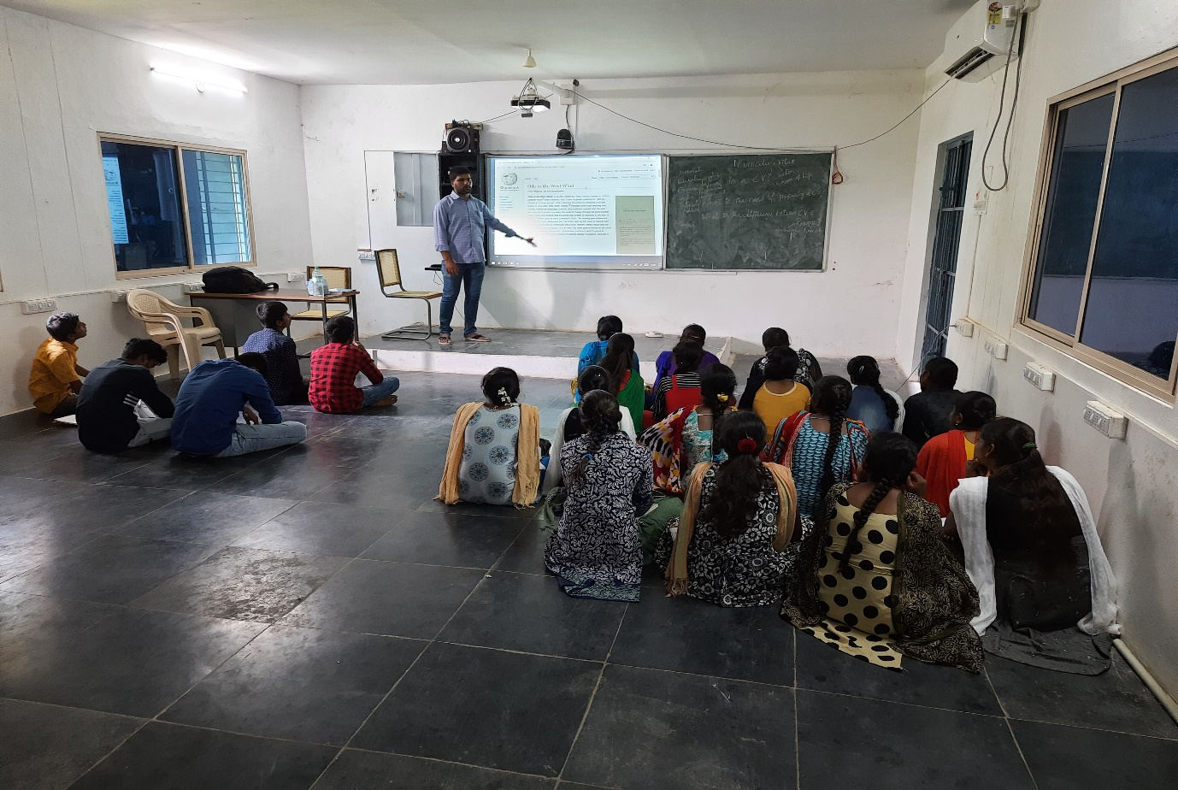

Engaging remedial classes for II B. Sc students
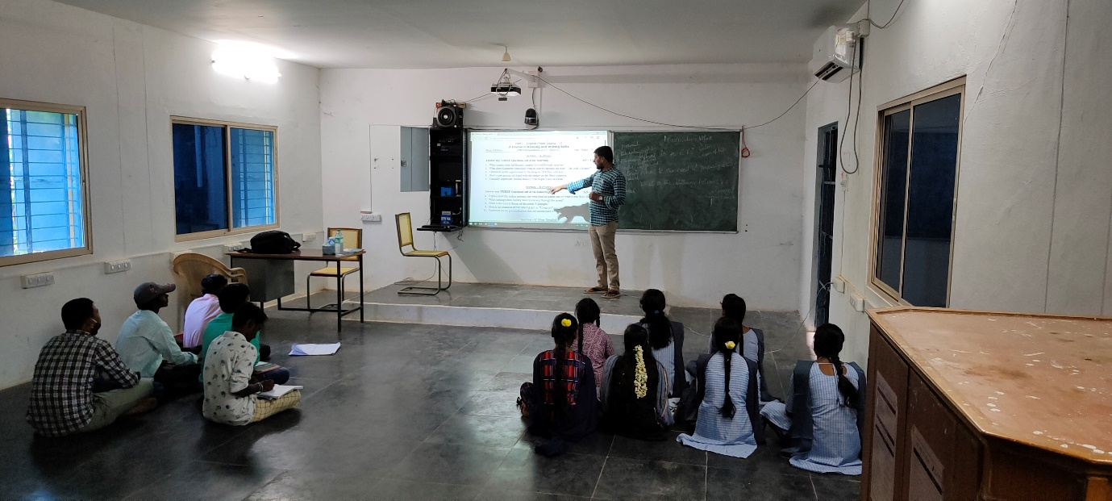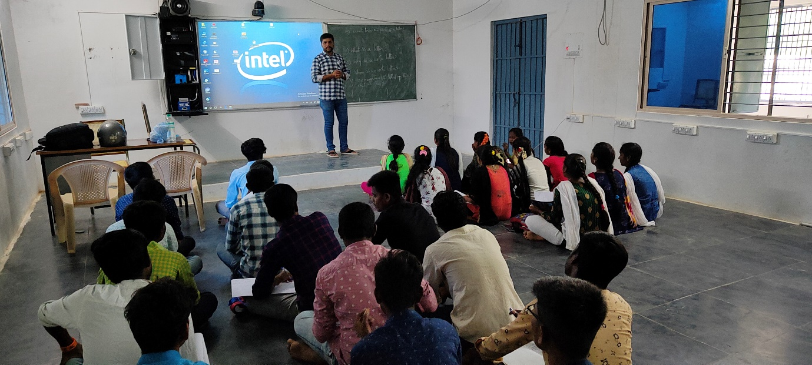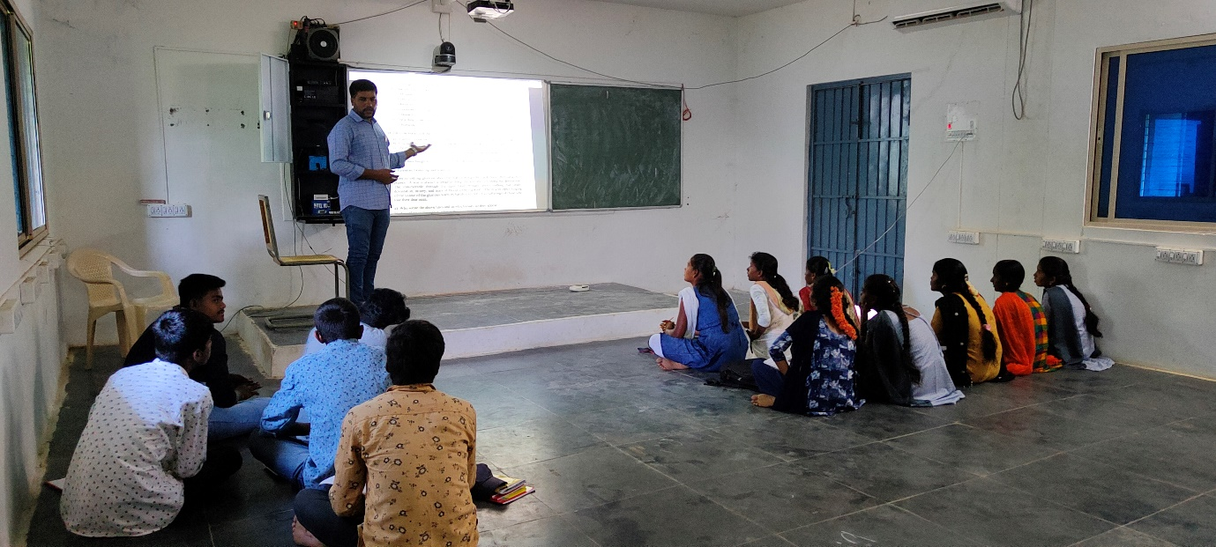
REMEDIAL CLASSES ON COMPREHENSION PASSAGES

SYTR GOVT DEGREE COLLEGE

MADAKASIRA

DEPARTMENT OF ENGLISH

ACADEMIC YEAR – 2022-23

Engaging Remedial Classes to Second Year Students

